

American International University-Bangladesh (AIUB)  
Department of Computer Science  
Faculty of Science &Technology (FST)  
Spring 21 22

Section: C  
Software Quality Assurance and Testing

Online Helping Hand Service

A Report submitted

By

|  |  |  |
| --- | --- | --- |
| SN | Student Name | Student ID |
| 1 | Rahman, Shabrina | 18-38514-2 |
| 2 | Jim, Jamiul Fariyah Jasim | 18-38540-2 |
| 3 | Fahim Mahtab | 18-38626-2 |
| 4 | Md. Rahat | 18-38665-3 |

Under the supervision of

Abhijit Bhowmik

Associate Professor, Dept. of CS

Software Test Plan

for

<Online helping hand service>

Version 1.0 approved

Prepared by <Rahman, Shabrina>

<Jim, Jamiul Fariyah Jasim>

<Fahim Mahtab>

<Md. Rahat>

<American International University-Bangladesh (AIUB)>

<26/04/2022>

Table of Contents

Revision History 3

1. TEST PLAN IDENTIFIER: RS-MTP01.3 3

2. REFERENCES 3

3. INTRODUCTION 3

Background to the Problem 3

Solution to the Problem 4

4. REQUEIREMNT SPECIFICATION 4

4.1 System Features 4

4.2 System Quality Attributes 4

4.3 System Interface 5

4.4 Project Requirements 5

5. FEATURES NOT TO BE TESTED 5

6. TESTING APPROACH 5

6.1 Testing Levels 5

6.2 Test Tools 6

6.3 Meetings 6

7. TEST CASES/TEST ITEMS 6

8. ITEM PASS/FAIL CRITERIA 7

9. TEST DELIVERABLES 7

10. STAFFING AND TRAINING NEEDS 8

11. RESPONSIBILITIES 8

12. TESTING SCHEDULE 8

13. PLANNING RISKS AND CONTINGENCIES 9

14. APROVALS 9

# Revision History

|  |  |  |  |
| --- | --- | --- | --- |
| Revision | Date | Updated by | Update Comments |
| 0.1 | 22.04.2022 | Md. Rahat | First Draft (Background problem, Solution) |
| 0.2 | 23.04.2022 | Rahman, Shabrina | Second Draft |
| 0.3 | 24.04.2022 | Jim, Jamiul Fariyah Jasim | Third Draft |
| 0.4 | 25.04.2022 | Fahim Mahtab | Fourth Draft |
| 0.5 | 26.04.2022 | Md. Rahat | Final Draft Complete |
|  |  |  |  |
|  |  |  |  |
|  |  |  |  |
|  |  |  |  |

# TEST PLAN IDENTIFIER:RS-MTP01.3

# REFERENCES

* [Ballista99] http://www.cs.cmu.edu/afs/cs/project/edrc-ballista/www/
* Ballista COTS Software Robustness Testing Harness homepage.
* [Basili85] Victor R. Basili, Richard W. Selby, Jr. "Comparing the Effectiveness of Software Testing Strategies",
* Technical Report, Department of Computer Science, University of Maryland, College Park, 1985.
* [Beizer90] Boris Beizer, Software Testing Techniques. Second edition. 1990
* A very comprehensive book on the testing techniques. Many testing techniques are enumerated and discussed in detail. Domain testing, data-flow testing, transactin-flow testing, syntax testing, logic-based testing, etc.
* [Beizer95] Beizer, Boris, Black-box Testing: techniques for functional testing of software and systems. Publication info: New York : Wiley, c1995. ISBN: 0471120944 Physical description: xxv, 294 p.: ill. ; 23 cm.
* This book is a comprehensive introduction to various methods of testing, using intuitive examples. Complete coverage of all important testing techniques, and up-to-date. The focus is black-box/functional testing. The author is an internationally known software consultant with almost four decades of experience in the computer industry.
* [Duran84] Joe W. Duran, Simeon C. Ntafos, "An Evaluation of Random Testing", IEEE Transactions on Software Engineering, Vol. SE-10, No. 4, July 1984, pp438-443.
* This research investigates the effectiveness of random testing, in comparison of other testing methods. It convinces us that random testing method is much more powerful than it appears and should be deployed more.
* [Hetzel88] Hetzel, William C., The Complete Guide to Software Testing, 2nd ed. Publication info: Wellesley, Mass. : QED Information Sciences, 1988. ISBN: 0894352423.Physical description: ix, 280 p. : ill ; 24 cm.
* This book is a good guide to software testing. But it may not be as complete a guide as it was 10 years ago.
* [Howden87] William E. Howden. Functional program Testing and Analysis. McGraw-Hill, 1987.
* In-depth discussion about functional testing throughout all product life-cycle.
* [IEEE90] IEEE Standard Glossary of Software Engineering Terminology (IEEE Std 610.12-1990), IEEE Computer Soc., Dec. 10, 1990.
* Terminology standard.
* [Kaner93] Cem Kaner, Testing Computer Software. 1993.
* Discusses the purpose and techniques for software testing.
* [Lyu95] Michael R. Lyu , Handbook of Software Reliability Engineering. McGraw-Hill publishing, 1995, ISBN 0-07-039400-8
* See topic Software Reliability reference.
* [Myers79] Myers, Glenford J., The art of software testing, Publication info: New York : Wiley, c1979. ISBN: 0471043281 Physical description: xi, 177 p. : ill. ; 24 cm.

# INTRODUCTION

## Background to the Problem

Nowadays technology is talking to us. In every day we use technology through different kind of electronic devices. Using those devices, we can communicate with each other very easily. Not only devices, we use Car, Computer, Tv, Refrigerator, Air Conditioner, Washing Machine, and many other electronic inventions to make our life easy and comfortable. But sometimes those devices do not work properly because of some internal damage. At that time, we have to suffer a lot and need quick repairment. But lack of mechanical information in our mind, we cannot repair our device immediately.

The root reason for this problem is the lack of better mechanical information. For this reason, we have to face many problems besides we are currently passing a pandemic situation. So, it is exceedingly difficult to find a mechanic who can fix our device immediately.

## Solution to the Problem

The solution to this problem is using a software-Online Helping Hand Service. Through using this Software user can keep track of all the mechanics in his/her area by using GPS and contact them via our system, where user can send specific photo of their device, also they can chat or call directly.

In the software there is hand held device section, home appliance section, Software fixing section. In all these sections contains information’s about their individual characters. So that the user can find their problem related section easily.

Our system is complete software, which is user-friendly Web-Based Software. There is a special feature we are providing a feedback option, where the user can give their opinion about our services.

# REQUEIREMNT SPECIFICATION

## System Features

In our system, there are some system features including system login, admin panel or control panel, system security.

* + System login: The software shall allow users to login with their given username and password. If the username and / or password has been inserted wrong more than three times, the random verification code will be generated by the system to retry login. If the number of login attempts exceed its limit (5 times), the system shall block the user account for 20 minutes. [Functional Requirements].
  + Control Panel: The registered admin can add/delete/modify the sections of shop, edit or update shop details. If unusual activates happened an Admin can block the user via control panel.

* + System Security: If a user’s account is frozen or they have forgotten their password/username they can recover it via their registered e-mail. For every account recovery the system will notify the admin. If the system notifies any unusual login attempt the system will block the user for 24 hours. An account can be logged into multiple devices but at a time an account can function only in 1 device.

## System Quality Attributes

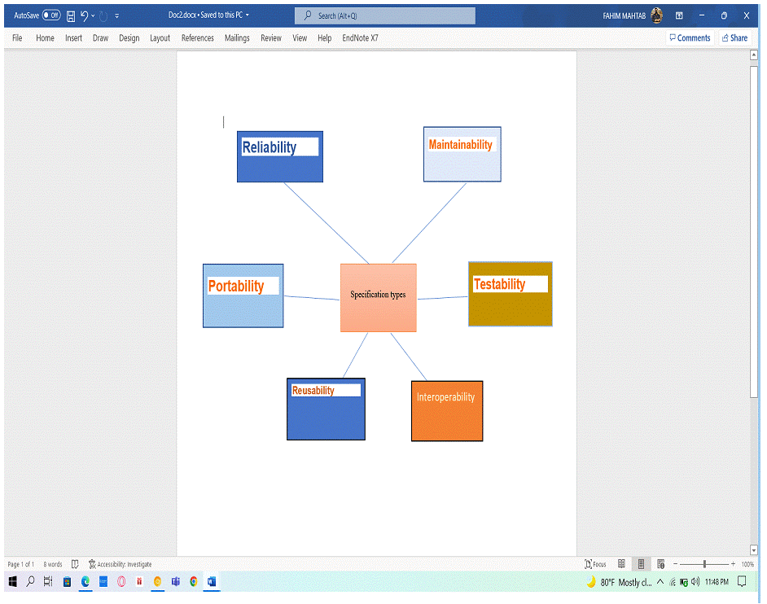

**Reliability**

Measure if the product is reliable enough to sustain in any condition. Should give the correct results consistently. Product reliability is measured in terms of working of the project under different working environments and different conditions.

**Maintainability**

Different versions of the product should be easy to maintain. For development, it should be easy to add code to the existing system, should be easy to upgrade for new features and new technologies from time to time.

Maintenance should be cost-effective and easy. The system is easy to maintain and correct defects or make a change in the software.

**Portability**

This can be measured in terms of Costing issues related to porting, Technical issues related to porting, and Behavioral issues related to porting.

**Testability**

The system should be easy to test and find defects. If required, it should be easy to divide into different modules for testing.

**Reusability**

Software reuse is a good cost-efficient and time-saving development method. Different code library classes should be generic enough to be easily used in different application modules. Divide the application into different modules so that modules can be reused across the application.

**Interoperability**

Interoperability of one system to another should be easy for the product to exchange data or services with other systems. Different system modules should work on different operating system platforms, different databases, and protocol conditions.

## System Interface

* At first, users will have to register to the system. After Registration the User can Login with their registered credentials.

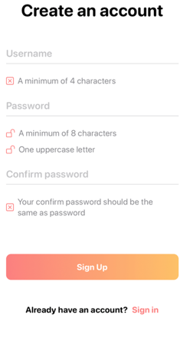 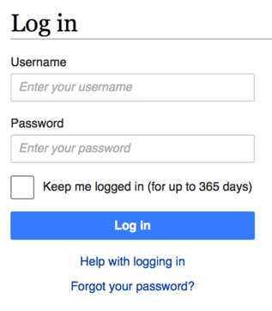

Fig 1: Registration Page Fig 2: Login Page

## Project Requirements

* List of project constraints (e.g., time, budget, resources, environment, etc.) that should be followed in the project management is shown below with calculation.
* Developer salary per working hour=600 taka.

22 days working day in a month and 7 hours working hours in day.

1 Months=1*22*7=154 working hours.

Total developer salary=600*154=92400 Taka

* Requirement analysis,

Time 1 month=22 working days*7 working hour = 154 working hour

Hourly wage of 1 requirement analysis person= 500 taka

Total cost= 500*154 =77000 Taka

* Transport

10000 Taka

* Hardware Expenses

Hardware Expenses= 80,000 Taka

* Rent service:

Room per month :15000 taka

* Maintenance cost

Maintenance cost= Required time 100 hours

Per hour cost 1000 taka

Net total cost=1000*100=100000 Taka

Training cost= 10,000 Taka

Total estimation cost= 92400 + 77000 + 10000 + 80000 + 15000 + 100000 + 10000

= 384400 takas

Now for development time -

* Development Time: 6 MONTHS

# FEATURES NOT TO BE TESTED

The system does not trace the live location of the mechanics as it does not have the GPS tracing feature. The admin panel will input the location manually.

# TESTING APPROACH

## Testing Levels

The testing for the online helping hand service project will consist of Unit, System/Integration (combined) and Acceptance test levels. These testing levels are needed to define any gaps in the development lifecycle and to clarify the various levels. Most testing will be done by the test manager with the development teams’ participation.

* UNIT Testing: Unit testing is the first level of software testing and it is used to determine whether software modules meet the specified requirements. This testing will be done by the developer as part of the project implementation. The project's test rule will be defined by the project manager. At each meeting, the PM will review the report and take the required steps to advance the project. It is a lower level/ initial level testing.
* INTEGRATION Testing: It is performed by the test manager and development team leader with assistance from the individual developers as required. The major goal of performing integration testing is to find flaws in the interaction between integrated components or units. This report will be checked by the project manager and test manager.
* SYSTEM Testing: It's called end-to-end testing since the testing and production environments are identical. We will test the application as a whole system at the third level of software testing. System testing enables us to test, verify, and validate both the business requirements as well as the application architecture.
* ACCEPTANCE Testing: With the help of the test manager and development team leader, will be carried out by actual end users. After that, it will be accessible in beta. Further improvement will be accomplished with the assistance of feedback. The testing team can reduce how an application performs in production by running acceptance tests on it. Acceptance of the system is also open to legal and contractual criteria.
* PERFORMANCE Testing: In terms of the following aspects, performance testing is considered to be one of the most important and mandatory testing types:
  + Speed
  + Capacity
  + Stability
  + Scalability

Performance testing can be qualitative or quantitative, and it's divided into sub-types like Load testing and Stress testing.

* PORTABILITY Testing: It will be done by the developer team.

## Test Tools

The only test tools to be used is selenium.

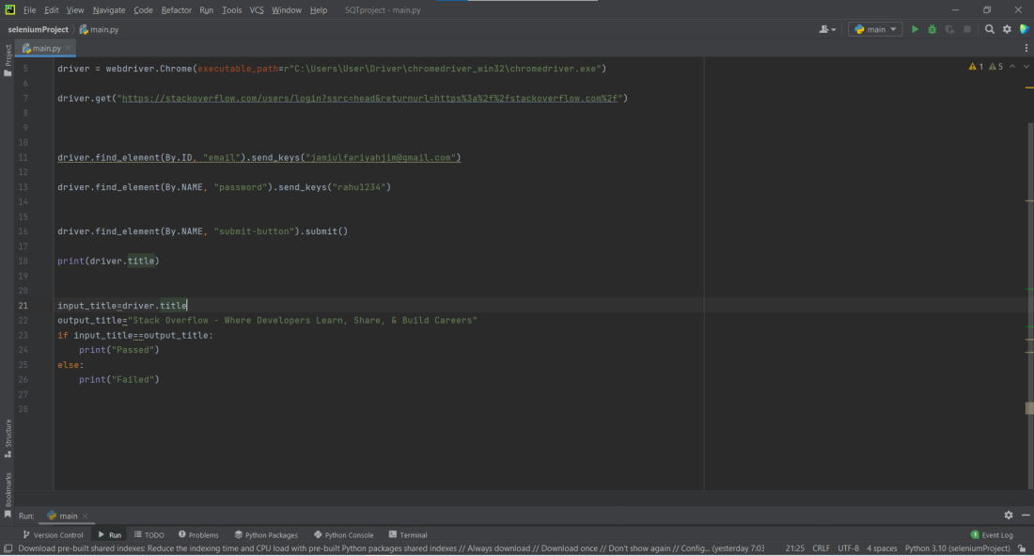

Fig1: App testing

First, install python then PyCharm for IDE.

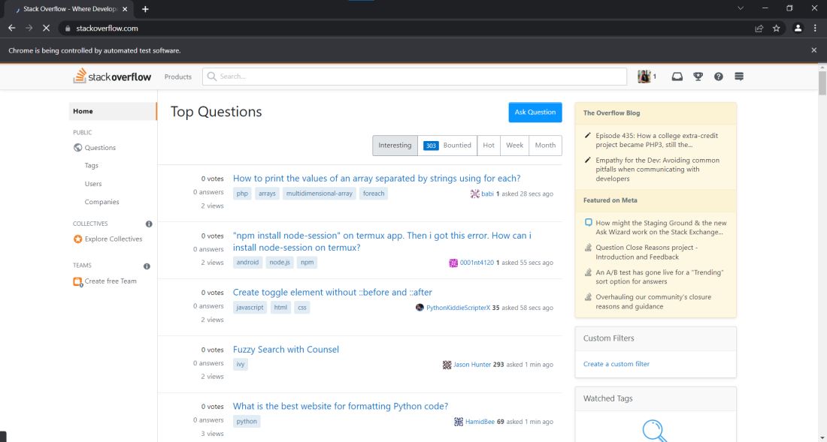

Fig2: Log in page

After login stack overflow it will appear this page.

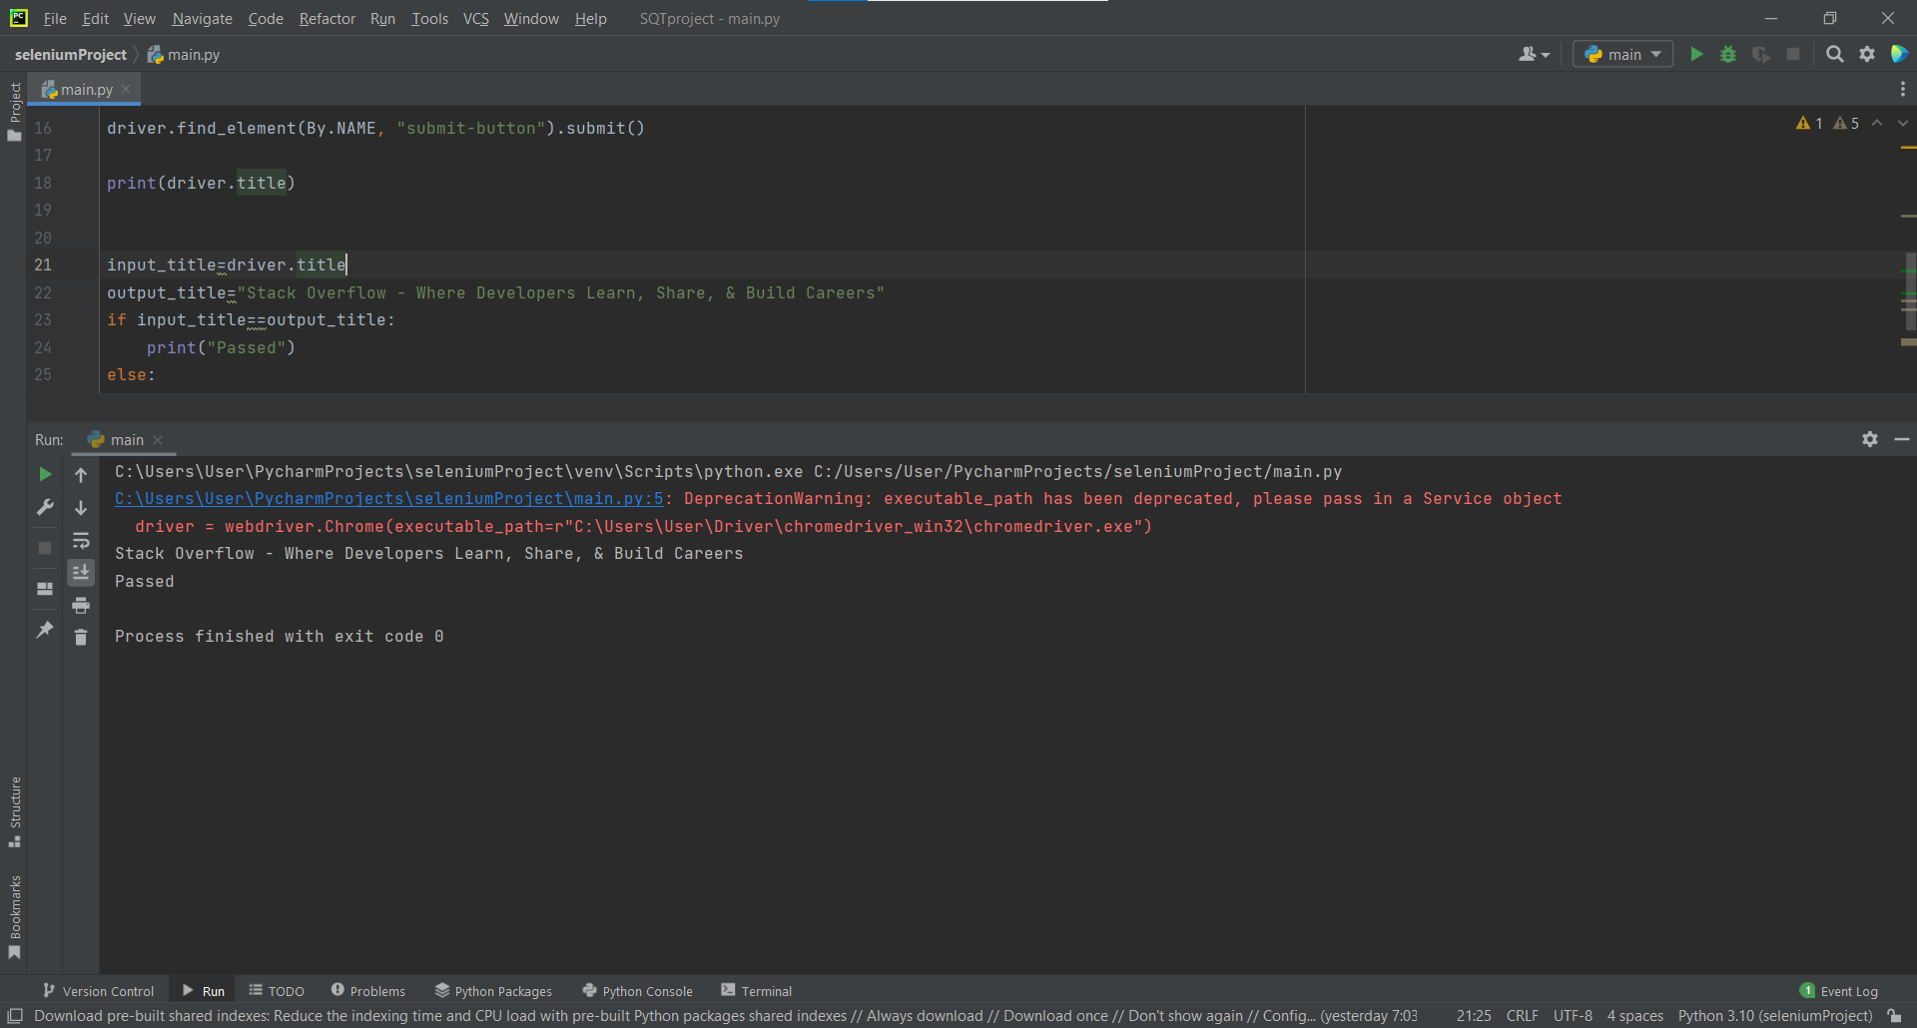

Fig3: Output

## Meetings

The test team will meet once every two weeks to evaluate progress to date and to identify error trends and problems as early as possible. The test team leader will meet with development and the project manager once every two weeks as well. These two meetings will be scheduled on different weeks. Additional meetings can be called as required for emergency situations.

# TEST CASES/TEST ITEMS

Number: 1

|  |  |  |  |  |  |
| --- | --- | --- | --- | --- | --- |
| Project Name: Online Helping Hand Service | | | Test Designed by: Rahat | | |
| Test Case ID: 1 | | | Test Designed date: 15/04/22 | | |
| Test Priority (Low, Medium, High): Medium | | | Test Executed by: Rahat | | |
| Module Name: Login Session | | | Test Execution date: 15/04/22 | | |
| Test Title: verify login with valid username and password | | |  | | |
| Description: In app login page | | |  | | |
| Precondition (If any): User must have valid username and password | | | | | |
| Test Steps | Test Data | Expected Results | | Actual Results | Status (Pass/Fail) |
| 1. Go to the website 2. Enter username 3. Enter password 4. Click submit | Username: 99999999999  Password: 321 | User should login into the application | | As expected, | Pass |
| Post Condition: User is validated with database and successfully login to account. The account session details are logged in the database. | | | | | |

Number: 2

|  |  |  |  |  |  |
| --- | --- | --- | --- | --- | --- |
| Project Name: Online Helping Hand Service | | | Test Designed by: Rahat | | |
| Test Case ID: 2 | | | Test Designed date: 16/04/22 | | |
| Test Priority (Low, Medium, High): Medium | | | Test Executed by: Jim | | |
| Module Name: Login Session | | | Test Execution date: 16/04/22 | | |
| Test Title: verify login with valid username and password | | |  | | |
| Description: In app login page | | |  | | |
| Precondition (If any): User must have valid username and password | | | | | |
| Test Steps | Test Data | Expected Results | | Actual Results | Status (Pass/Fail) |
| 1. Go to the website 2. Enter username 3. Enter password 4. Click submit | Username: abc  Password: 321 | User should not login into the application | | As expected, | Fail |
| Post Condition: User is invalidated with database and unsuccessfully login to account. The account session details are logged in the database. | | | | | |

Number : 3

|  |  |  |  |  |  |
| --- | --- | --- | --- | --- | --- |
| Project Name: Online Helping Hand Service | | | Test Designed by: Jim | | |
| Test Case ID: 3 | | | Test Designed date: 16/04/22 | | |
| Test Priority (Low, Medium, High): Medium | | | Test Executed by: Shoshi | | |
| Module Name: Login Session | | | Test Execution date: 16/04/22 | | |
| Test Title: verify user if password is wrong | | |  | | |
| Description: in app login page | | |  | | |
| Precondition (If any): User must have valid username and password | | | | | |
| Test Steps | Test Data | Expected Results | | Actual Results | Status (Pass/Fail) |
| 1. Go to the website 2. Enter username 3. Enter password 4. Click submit | Username: 99999999999  Password: 111 | User should login into the application | | As expected, | Fail |
| Post Condition: After 3 attempts the user have to verify with a code to enter and reset the account and if the user try’s 5 times continuously, he will be blocked 20 mins. | | | | | |

# ITEM PASS/FAIL CRITERIA

⦁ Every item must be check

⦁ Each and every item will test

⦁ All result needs to match with desired result

⦁ If any of unit fail to meet desired result then it considers as fail

⦁ If there is no error then all the units will pass

9 TEST DELIVERABLES

⦁ Testing reports

⦁ Test plan document

⦁ Acceptance test report

⦁ Test execution report

⦁ Test bugs or error reports

⦁ Budget report

⦁ Test case

⦁ Summary report

# 10. STAFFING AND TRAINING NEEDS

In this project testing is the crucial part. Before deliver a project to customer all things need to be done. Each and every module tested by the developer before deadline. Because testing criteria is little bit of lengthy process. If there is any fault in any module then rechecks and correct mistakes. So, developer should be very careful. Manual testing is also done to improve performance. For testing all things, needs to be skillful workers. If there is no skill, then give some training to improve the skills of worker.\

# 11. RESPONSIBILITIES

|  |  |  |
| --- | --- | --- |
| Responsibility | Name | Role |
| Verifying Test Plan | Jim, Jamiul Fariyah Jasim | Test Lead |
| Writing Test Case | Fahim Mahtab | Test Engineer |
| Acceptance Test Documentation & Execution | Rahman, Shabrina | Test Lead |
| Unit Test Documentation & Execution | Fahim Mahtab | Junior Tester |
| Validating Project changes | Md Rahat | Project Manager |
| Regression Test and Control Changing | Jim, Jamiul Fariyah Jasim | Test Engineer, Junior Tester |
| Rules & Procedures | Md Rahat | Test Lead, Junior Developer |
| Design Reviews | Rahman, Shabrina | Test Lead, Project Manager, Junior Tester |
| Test Documentation & Execution | Md Rahat | Test Engineer, Junior Tester |

# 12. TESTING SCHEDULE

Time has been allocated within the project plan for the following testing activities. The specific dates and times for each activity are defined in the project plan timeline. The people required for each process are detailed in the project timeline and plan as well. Coordination of the personnel required for each task, test team, development team, management and customer will be handled by the project manager in conjunction with the development and test team leaders.

|  |  |  |  |
| --- | --- | --- | --- |
| Sl. | Task Name | Duration | Start |
| 1 | Documentation | 10 days | 10-04-2022 |
| 2 | Design | 30 days | 25-04-2022 |
| 3 | Test plan | 10 days | 25-05-2022 |
| 4 | Unit testing | 10 days | 10-06-2022 |
| 5 | Integration testing | 10 days | 10-07-2022 |
| 6 | System Testing | 50 days | 24-07-2022 |
| 7 | Acceptance Testing | 30 days | 22-10-2022 |
| 8 | Evaluating Acceptance Criteria | 30 days | 30-01-2023 |

# 13. PLANNING RISKS AND CONTINGENCIES

Every project has some risks and contingencies. Sometimes one of the group members may be sick because of one person missing the works load more. Or some other time developers can’t meet the deadline. Due to less invest project may delay or not so good.

# 14.APROVALS

|  |  |
| --- | --- |
| Project sponsor | Abhijit Bhowmik |
| Development management | Md Rahat |
| Project manager | Md Rahat |
| Test Engineer | Jim, Jamiul Fariyah Jasim |
| Junior Tester | Rahman, Shabrina |
| Junior Developer | Fahim Mahtab |
| Junior Tester | Fahim Mahtab |